**GMDL, HW#2**אורן יקואל – 208727164 , יונתן לויטס - 336132014, גל אלון – 318512910

**Problem 1:**

We’ll show that $argmax_{\left(θ_{1}, …, θ_{k}, π_{1}, …, π_{k}\right)}Q(θ,θ^{t})$ s.t $\sum_{k=1}^{K}{π_{k}}=1$.   
As we saw in class we know that: $Q\left(θ,θ^{t}\right)=\left(\sum_{i=1}^{N}{\sum_{k=1}^{K}{r_{i,k}^{t}}}\log{π_{k}}\right)+ (\sum_{i=1}^{N}{\sum_{k=1}^{K}{r_{i,k}^{t}}}\log{N(x_{i};μ_{k},Σ_{k}})$ 
   
Let’s denote a LaGrange multiplier function, with the constraints: $$L\left(π_{k},λ\right)=\left(\sum_{i=1}^{N}{\sum_{k=1}^{K}{r_{i,k}^{t}}}\log{π_{k}}\right)+λ(\sum_{k=1}^{K}{π_{k}}-1)$$ 
So we’ll partially derive: $\frac{∂L\left(π_{k},λ\right)}{∂π_{k}}=(\sum_{i=1}^{N}{\frac{r_{i,k}^{t}}{π_{k}}})+λ$ 
 and $\frac{∂L\left(π_{k},λ\right)}{∂λ}= \sum_{k=1}^{K}{π_{k}}-1$  
So: $(\sum_{i=1}^{N}{\frac{r_{i,k}^{t}}{π_{k}}})+λ=0$ $\sum_{i=1}^{N}{\frac{r_{i,k}^{t}}{π_{k}}}= -λ →\frac{1}{π_{k}} \sum_{i=1}^{N}{r_{i,k}^{t} }=-λ→π_{k}= \frac{-\sum_{i=1}^{N}{r_{i,k}^{t} }}{λ}$ 
   
And: $\sum_{k=1}^{K}{π_{k}}-1=0→ \sum_{k=1}^{K}{π_{k}}=1$  
together: $\sum_{k=1}^{K}{\frac{-\sum_{i=1}^{N}{r_{i,k}^{t} }}{λ}}=1→λ=-\sum_{k=1}^{K}{\sum_{i=1}^{N}{r_{i,k}^{t} }}$ 
   
We’ll recall, $$π_{k}= \frac{-\sum_{i=1}^{N}{r_{i,k}^{t} }}{λ}= \frac{\sum_{i=1}^{N}{r_{i,k}^{t} }}{\sum_{k=1}^{K}{\sum_{i=1}^{N}{r_{i,k}^{t} }}}= \frac{\sum_{i=1}^{N}{r_{i,k}^{t} }}{\sum_{i=1}^{N}{\sum_{k=1}^{K}{r_{i,k}^{t} }}}= \frac{\sum_{i=1}^{N}{r_{i,k}^{t} }}{\sum_{i=1}^{N}{1}}=\frac{\sum_{i=1}^{N}{r_{i,k}^{t} }}{N} ∎$$

**Problem 2:  
(i)** We’ll notice that if we choose $α_{k}=1$ $∀k$ we’ll get: $$Dir\left(π | α=1\right)= \frac{Γ(Σ_{k=1}^{K}1)}{Γ{\left(1\right)}^{K}}*Π_{k=1}^{K}1= \frac{Γ(K)}{Γ{\left(1\right)}^{K}}$$ 
Because we get an expression which doesn’t involve $π$, and is a close expression, we can say $Π$ is sampled from a uniform distribution.

**(ii)**  Uniform $π :π=\left[\frac{1}{k}, … , \frac{1}{k}\right]∈R^{k}$ On the other hand , $π$ that is sampled from uniform distribution is (as proven above): $$Dir\left(π | α=1\right)= \frac{Γ(Σ_{k=1}^{K}1)}{Γ{\left(1\right)}^{K}}*Π_{k=1}^{K}1= \frac{Γ(K)}{Γ{\left(1\right)}^{K}}$$  
Meaning, a uniform $π$ is a vector where entry is $\frac{1}{k}$ and $\left|π\right|=k$, while a $π$ that is sampled from uniform distribution is a vector that can receive any value with equal probability.

**(iii)** In the context of mixture models and estimating π , using the prior instead of a pure likelihood-based approach can prevent overfitting or misleading results. In particular, if the data set is too small or noisy, the prior can provide a useful source of information about the distribution, which can help better generalize new data.

For example, if we sampled 𝑁 (a relatively small number) samples from a mixture model and received data in which no sample comes from the entry with the largest weight – we’ll denote as c, then a likelihood-based calculation will give $π_{c}=0$. On the other hand, if we can assume in advance that the data is sampled from some distribution where $π_{c}$ gets a relatively high value with a high probability, then the model will give a more accurate value for $π_{c}$.

**Part 2:**  
Obviously, and as we saw the K parameter affects on how many different objects the model is trying to segment.

**K = 2:**

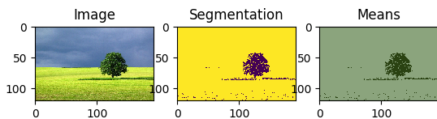

kappa = 1  
nu = 1000  
alphas = 100  
psi = 0.2  
m = 0.5

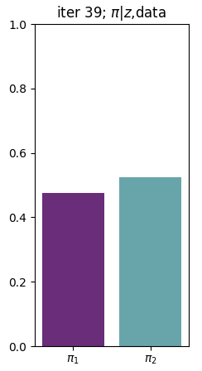

kappa = 1  
nu = 100  
alphas = 100  
psi = 0.2  
m = 0.5

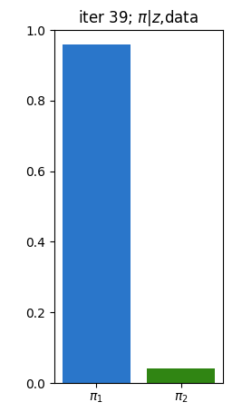

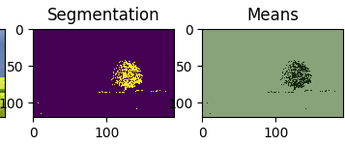

kappa = 1  
nu = 100  
alphas = 1000  
psi = 0.38  
m = 0.5

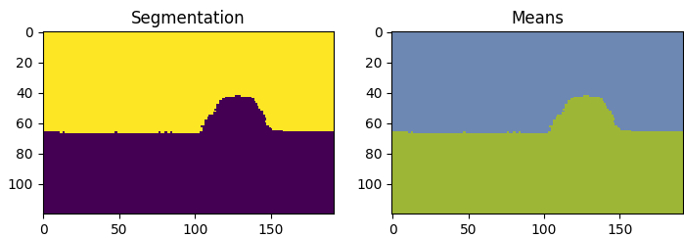

kappa = 1  
nu = 1000  
alphas = 100  
psi = 0.2  
m = 0.5

**K = 3:**

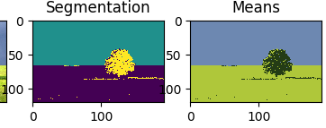

kappa = 10  
nu = 10000  
alphas = 100  
psi = 0.1  
m = 0.5

kappa = 1  
nu = 10000  
alphas = 100  
psi = 0.1  
m = 0.5

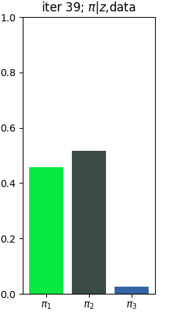

kappa = 1  
nu = 10000  
alphas = 100  
psi = 0.1  
m = 0.5

kappa = 1  
nu = 10000  
alphas = 10000  
psi = 0.1  
m = 0.5

**K = 4:**

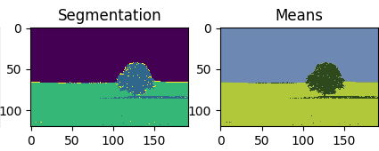

kappa = 1  
nu = 100  
alphas = 1000  
psi = 0.2  
m = 0.5

kappa = 1  
nu = 1000  
alphas = 1000  
psi = 0.3  
m = 0.5

kappa = 1  
nu = 5  
alphas = 1000  
psi = 0.2  
m = 0.5

kappa = 1000  
nu = 100  
alphas = 1000  
psi = 0.2  
m = 0.5

**Analysis of hyper parameters**

Alphas - Dirichlet Hyperparameters, higher values of alphas result in a more peaked prior distribution, favouring fewer dominant components in the image segmentation. A higher alpha can influence the likelihood of gaussian centre to be selected and create segments bigger than they should be.

Kappa – Controls the strength of the prior belief, larger kappa is more data-driven when smaller kappa is more faithful to the prior. We can see that for a larger kappa it shifts the weight towards the larger shapes in the image.

Nu – Represents the degree of freedom in the hyperparameters, seems that a higher value of nu allows more flexibility in the segmented shapes.

Psi - Represents the prior precision matrix of the covariance matrices, a lower psi value results in more detailed segmentation.

M – Represents the prior mean vector – couldn’t find any visible affect it has.